Case 6-Afr-Mali-Dogon-Crocodile Pirougue-Dual Wedding Party-Bronze-Early 20th c

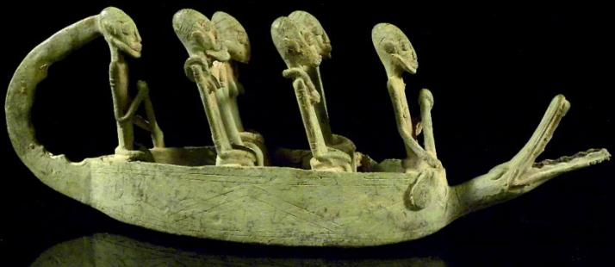

Dogon Crocodile Pirougue

Height x Width: 4.3 x 12,2 in. / 11 x 31 cm.;

Weight: 1.4 kg.

Bronze by Lost Wax Process

The mythic Dogon mythic crocodile

Although the crocodile is the major predator of man in west Africa, as a totem animal of certain clans, it was considered as a benevolent protector of clan members from drowning, as in this bronze wedding pirogue with a crocodile totem on the prow protecting the dual wedded couples on their wedding journey on the Niger River.